CERTIFICATE
This is to certify that the project titled “Personal Finance Management System” is a bonafide work carried out by GOBIKA S in partial fulfillment for the award of the degree under the subject Python.

ABSTRACT
The Personal Finance Management System is a Python-based application designed to help users manage their income, expenses, and savings efficiently. It provides features like expense tracking, budgeting, and financial analysis, helping users make better financial decisions. The system reduces manual effort and improves accuracy in managing personal finances.

INTRODUCTION
The Personal Finance Management System is developed to simplify the process of managing daily financial activities. It allows users to record income and expenses, categorize transactions, and monitor their financial status. By automating financial tracking, the system ensures better control over spending and promotes effective budgeting and savings habits

PROBLEM STATEMENT
- Difficulty in tracking daily expenses manually
- Lack of proper budgeting and financial planning
- High chances of calculation errors
- No clear analysis of income vs expenses
- Need for a simple and automated finance management system

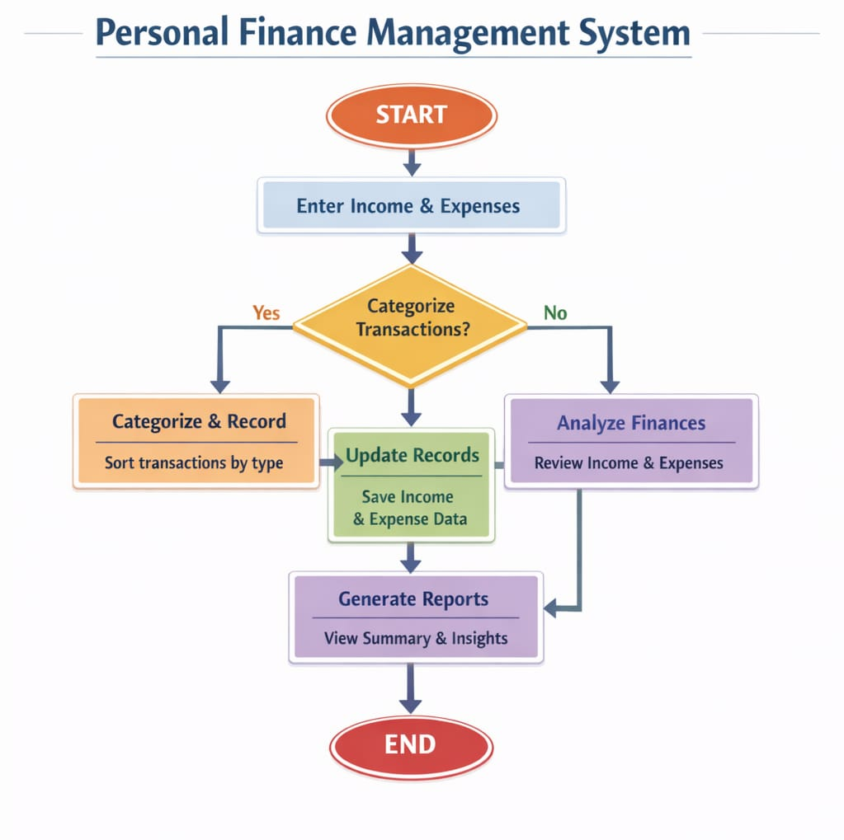
FLOWCHART

CODING
class FinanceManager:
def __init__(self):
self.income = 0
self.expense = 0

def add_income(self):
amt = float(input("Enter income amount: "))
self.income += amt

def add_expense(self):
amt = float(input("Enter expense amount: "))
self.expense += amt

def show_balance(self):
print("Total Income:", self.income)
print("Total Expense:", self.expense)
print("Balance:", self.income - self.expense)
fm = FinanceManager()

while True:
print("\n1.Add Income 2.Add Expense 3.Show Balance 4.Exit")
choice = int(input("Enter choice: "))

if choice == 1:
fm.add_income()
elif choice == 2:
fm.add_expense()
elif choice == 3:
fm.show_balance()
elif choice == 4:
break
else:
print("Invalid choice")

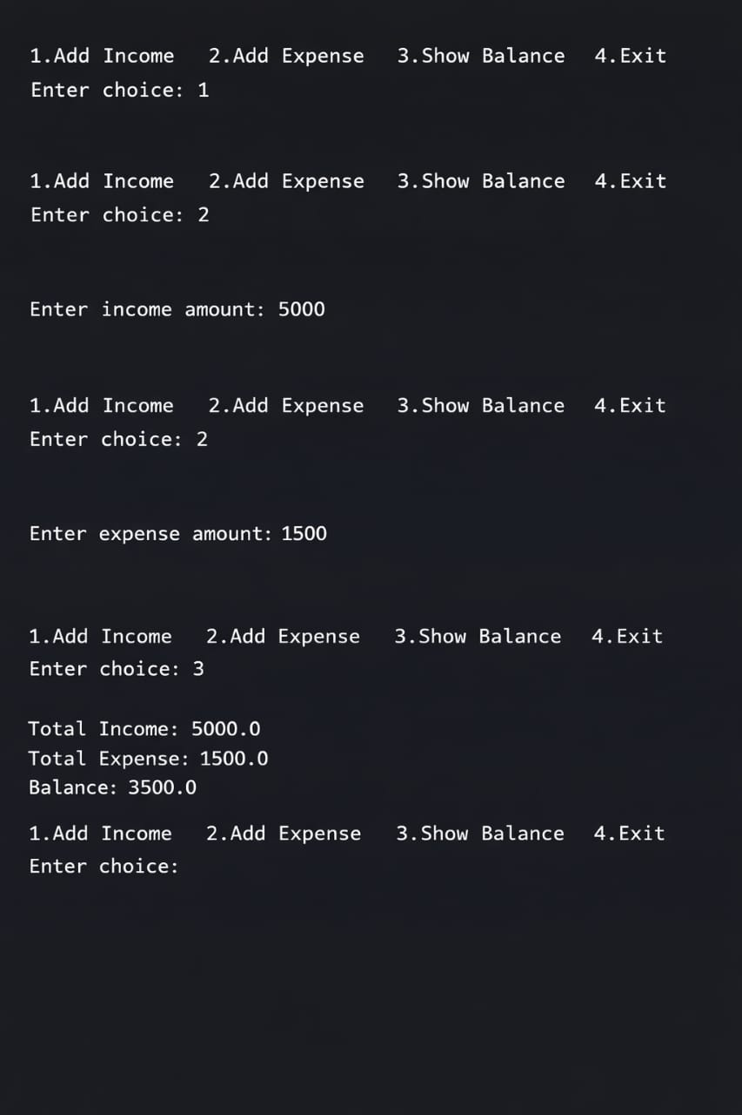
OUTPUT

CONCLUSION
The Personal Finance Management System provides a simple and efficient way to manage financial activities. It helps users track expenses, maintain budgets, and improve financial planning, making it a useful and user-friendly application.
.

